**SCREENSHOTS**



**Fig 1 Home Page**

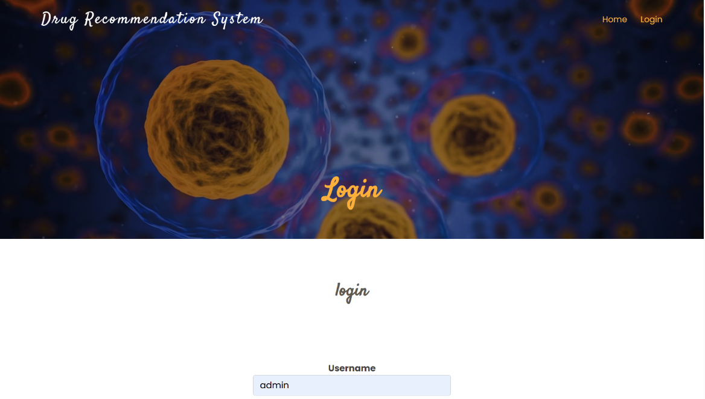

**Fig 2 Login Page**

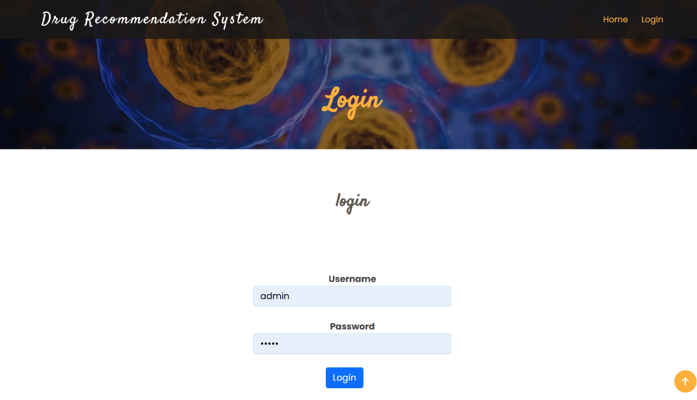

**Fig 3 Login Page**

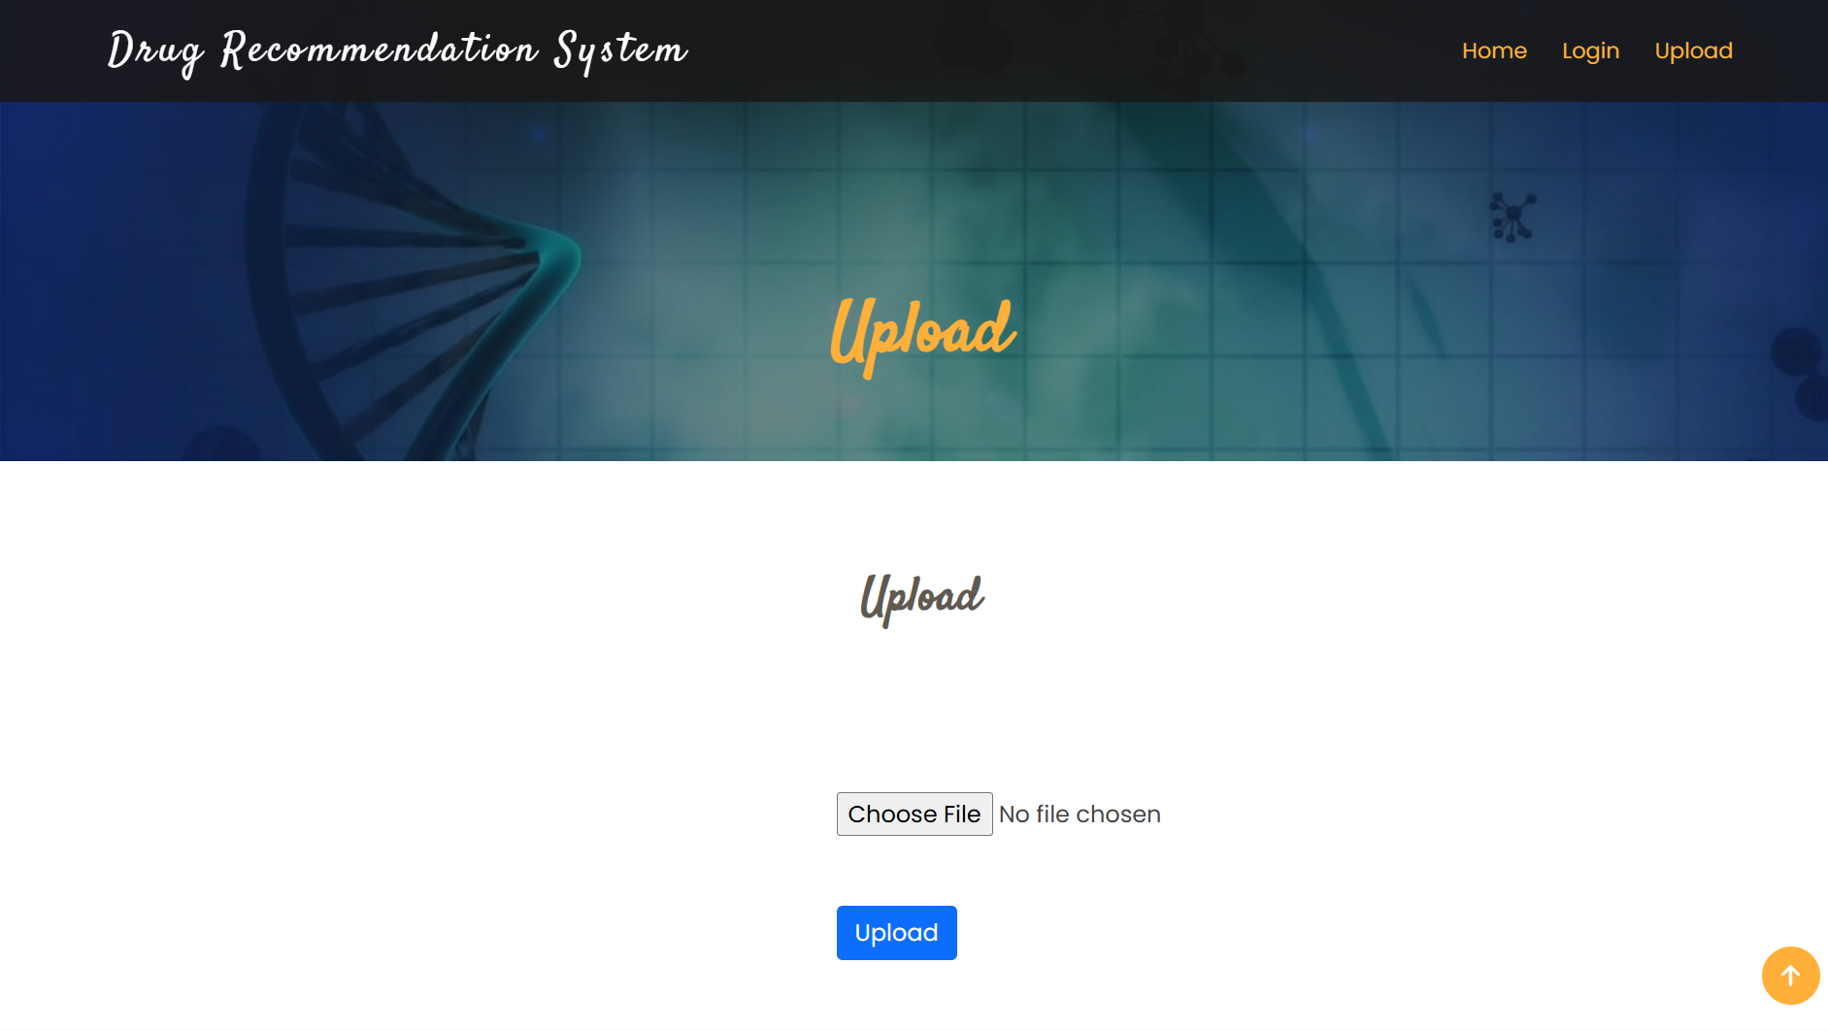

**Fig 4 Upload Page**

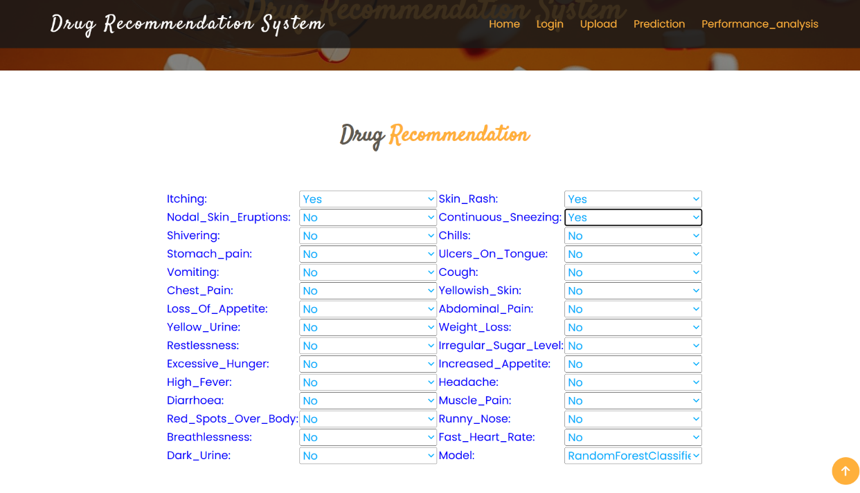

**Fig 5 Input Page**

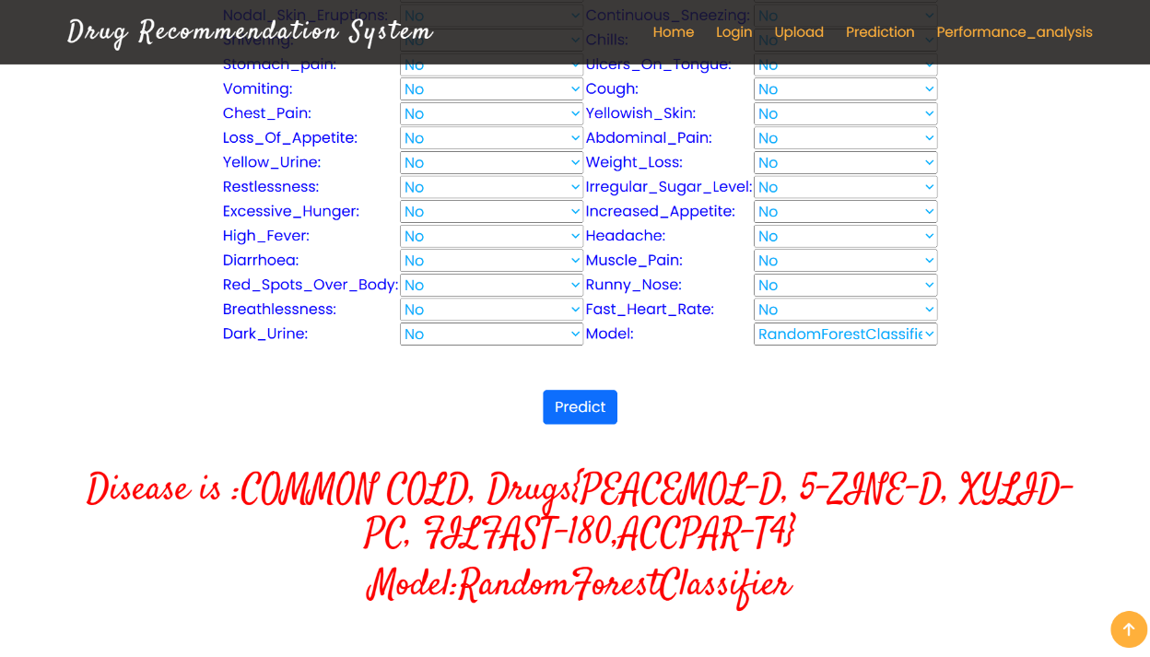

**Fig 6 Prediction Page**

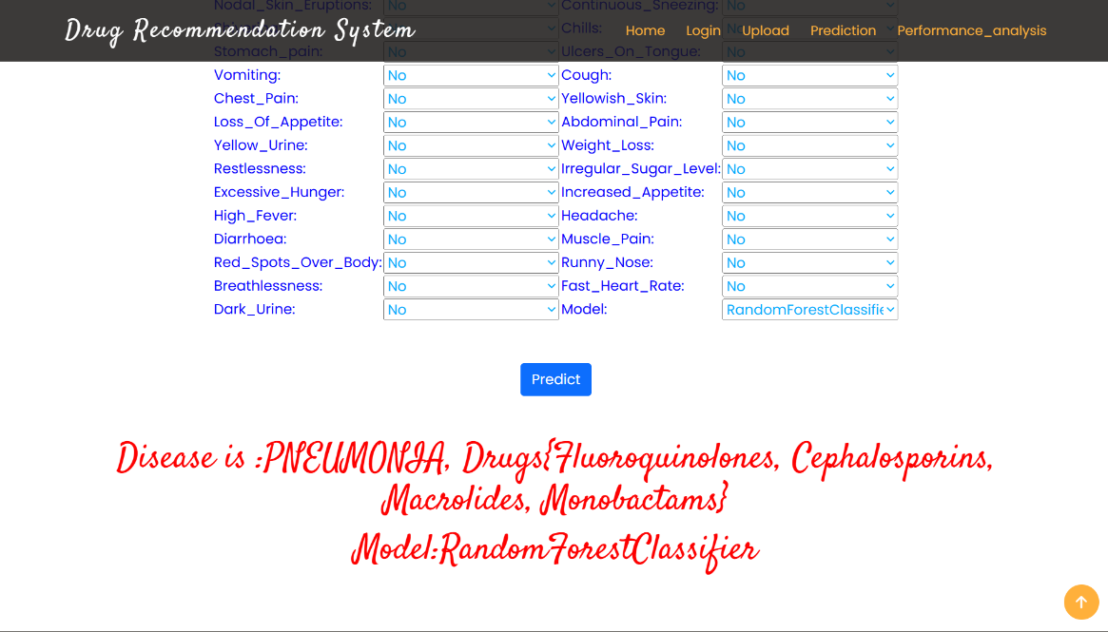

**Fig 7 Prediction Page**

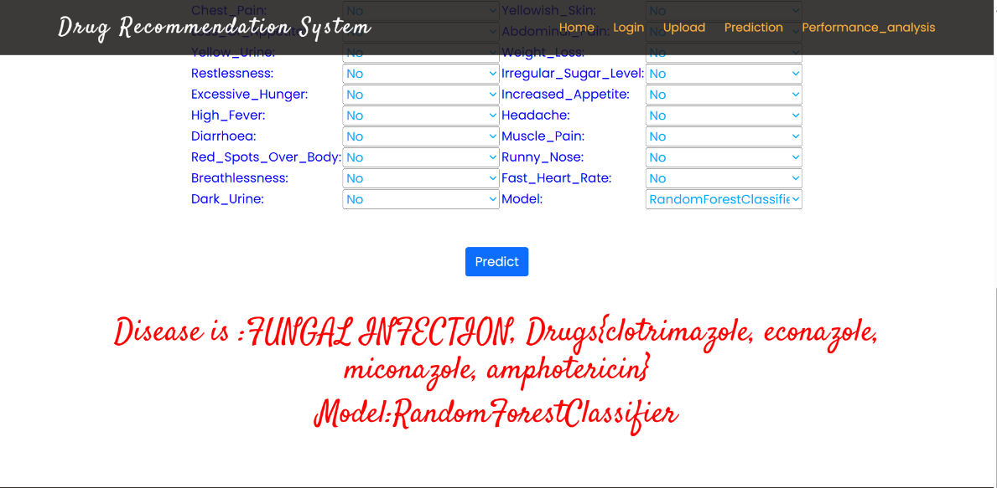

**Fig 8 Prediction Page**